South Australia
Government House Precinct Land Dedication Act 2016
An Act to dedicate certain land within the Government House precinct as a site for an ANZAC Centenary Memorial Garden Walk; to make related amendments to the National Soldiers Memorial Act 1949; to repeal the Government House Domain Dedication Act 1927; and for other purposes.

Contents
1 Short title
2 Commencement
3 Interpretation
4 Dedication of ANZAC Centenary Memorial Garden Walk land
5 Control of ANZAC Centenary Memorial Garden Walk land
6 Continuation of dedication of Government House Domain land
Schedule 1—Government House Precinct—Plan
Schedule 2—Related amendments and repeal
Part 1—Preliminary
1 Amendment provisions
Part 2—Amendment of National Soldiers Memorial Act 1949
2 Repeal of Preamble
3 Amendment of section 2—Control of National Soldiers Memorial
Part 3—Repeal of Government House Domain Dedication Act 1927
Legislative history

The Parliament of South Australia enacts as follows:
1—Short title
This Act may be cited as the Government House Precinct Land Dedication Act 2016.
2—Commencement
This Act will come into operation on a day to be fixed by proclamation.
3—Interpretation
In this Act, unless the contrary intention appears—
ANZAC Centenary Memorial Garden Walk land means the piece of land in the Hundred of Adelaide shown in the plan in Schedule 1 and marked "ANZAC Commemorative Walk";
Government House Domain land means the piece of land in the Hundred of Adelaide shown in the plan in Schedule 1 and marked "Government House Domain".
4—Dedication of ANZAC Centenary Memorial Garden Walk land
The ANZAC Centenary Memorial Garden Walk land is dedicated for the purpose of being used as a site for an ANZAC Centenary Memorial Garden Walk and for incidental purposes, and the land is reserved for all time for those purposes and must not be used for any other purpose.
5—Control of ANZAC Centenary Memorial Garden Walk land
The care, control, and management of the ANZAC Centenary Memorial Garden Walk land is vested in The Corporation of the City of Adelaide.
6—Continuation of dedication of Government House Domain land
Despite the repeal of section 2 of the Government House Domain Dedication Act 1927, the Government House Domain land continues to be land dedicated for the purpose of being used as a site for the residence of the Governor and for incidental purposes, and the land continues to be reserved for all time for those purposes and must not be used for any other purpose.

Schedule 1—Government House Precinct—Plan
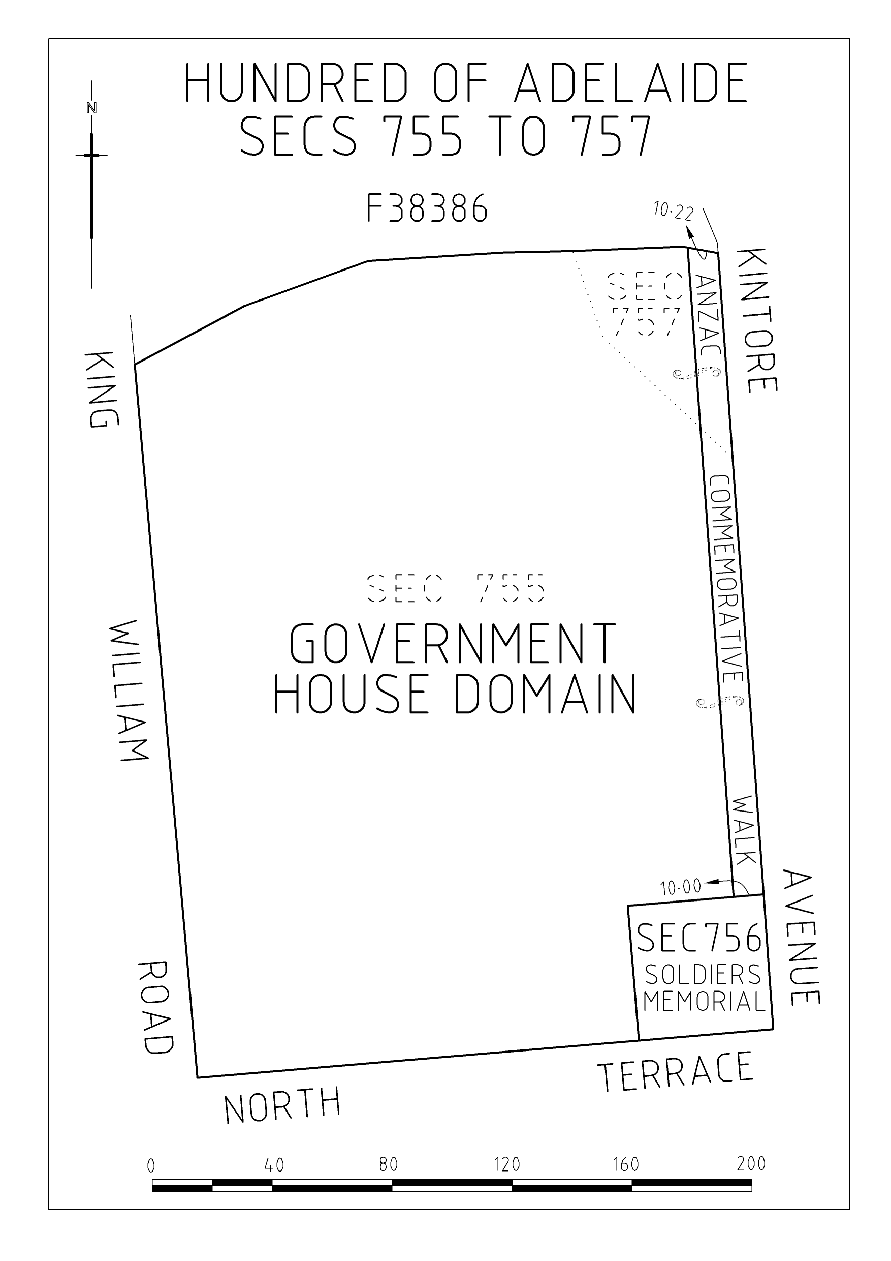

Schedule 2—Related amendments and repeal
Part 1—Preliminary
1—Amendment provisions
In this Schedule, a provision under a heading referring to the amendment of a specified Act amends the Act so specified.
Part 2—Amendment of National Soldiers Memorial Act 1949
2—Repeal of Preamble
Preamble—delete the Preamble
3—Amendment of section 2—Control of National Soldiers Memorial
Section 2(2)—delete subsection (2) and substitute:
(2) Despite the repeal of section 3 of the Government House Domain Dedication Act 1927, the land referred to in subsection (1) continues to be land dedicated for the purpose of being used as a site for a National Soldiers Memorial and for incidental purposes, and the land continues to be reserved for all time for those purposes and must not be used for any other purpose (and nothing in this Act is to be taken to affect or limit the dedication and reservation of that land).
Part 3—Repeal of Government House Domain Dedication Act 1927
The Government House Domain Dedication Act 1927 is repealed.

Legislative history
Notes
• For further information relating to the Act and subordinate legislation made under the Act see the Index of South Australian Statutes or www.legislation.sa.gov.au.
Principal Act
Year | No | Title | Assent | Commencement
2016 | 3 | Government House Precinct Land Dedication Act 2016 | 3.3.2016 | 24.3.2016 (Gazette 24.3.2016 p1026)

